ROBERTA FLACK LIVE IN BANGKOK
Show Date: Sunday 1 November 2009
Venue: Bangkok Convention Center, CENTARA Hotels and Resorts
Show time: 19.30 hrs
Ticket outlet: Thaiticketmajor.com
Ticket prices: 1,500 / 2,000 / 3,000 / 4,000 / 6,000 (Gold Package)THB
Call center: 0 2262 3456
Official Website: www.robertaflack.com

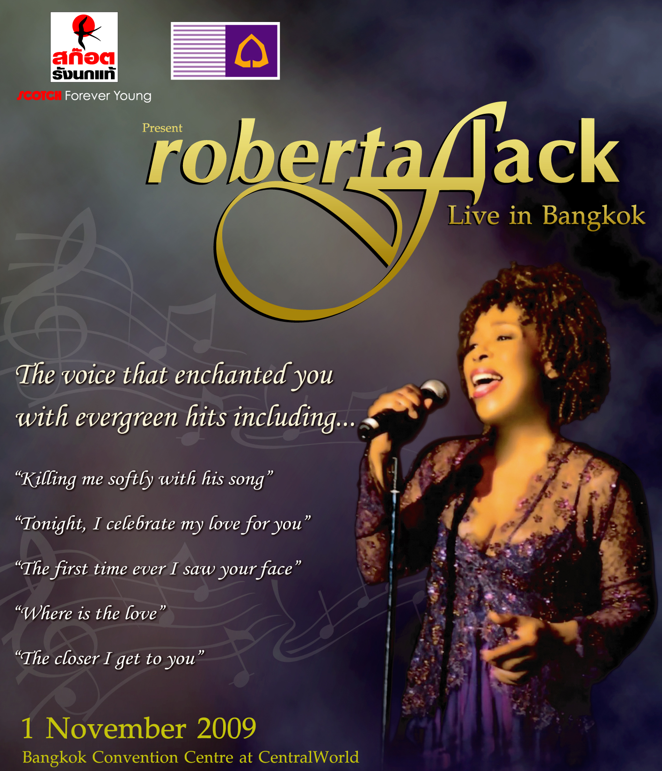

Scotch Forever Young & Siam Commercial Bank
present
ROBERTA FLACK LIVE IN BANGKOK
She has one of the most distinctive soul voices ever – and she’s coming to Thailand.
Roberta Flack will put on a fantastic and memorable concert this coming November 1 at the Bangkok Convention Center, Central World. The Grammy-winning jazz and R&B star has racked up a swag of hits over the last 40 years. Her timeless signature tunes include The First Time I Ever Saw Your Face which received two Grammy awards for Record of the Year and Song of the Year in 1973. She repeated this feat again in 1974 with Killing Me Softly With His Song which won Record of the Year, Best Pop Female Vocal and Song of the Year. Other hits include Feel Like Makin' Love, Where Is the Love and The Closer I Get to You.
Scotch Forever Young along with the Siam Commercial Bank present Roberta Flack Live in Bangkok November 1 at the Bangkok Convention Centre, Central World. Tickets are available from all Thaiticketmajor outlets at 1,500/2,000/3,000/4,000 and 6,000 Baht. For Gold Package privileges and discounts contact 02-262-3456 or visit www.thaiticketmajor.com.

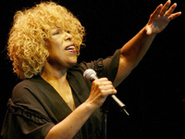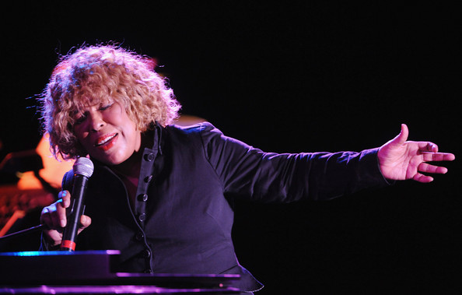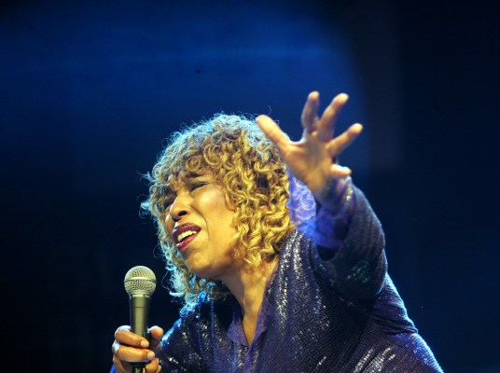

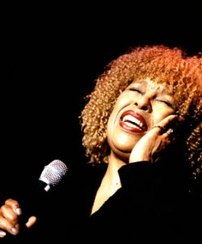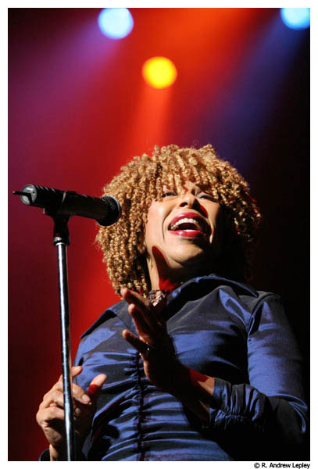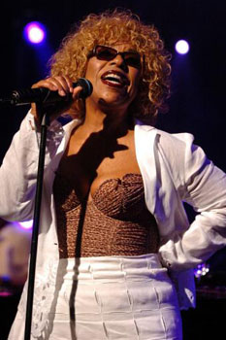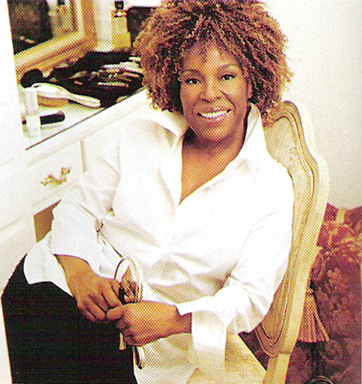
PR Department, BEC-Tero Entertainment Public Company Limited
Anongsiri PR Manager 089-927-6169 / anongsiri_pr@bectero.com
Payungjit 089-5112498 payungjit@bectero.com
Piyaphat 089-105-6879 piyaphat@bectero.com
Tel. 0-2262-3819,3885 Fax 0-2262-3921

Roberta Flack Biography
Born in Asheville, North Carolina, and raised in Arlington,Virginia, Roberta Flack discovered her earliest musical influences from the church. The local AME Zion Church gave everyone the opportunity to get out of the house, but, as Roberta recalls, the music "didn't have the raunchy, wide-open, free, spontaneous, full-of-life thing that you could hear at the Baptist Church down the street." Whenever she could, she'd sneak over there to hear such gospel luminaries as Mahalia Jackson and Sam Cooke with the Soul Stirrers. At home, Roberta's father repaired an old upright piano, and she began to pick out tunes while sitting on her mother's lap. When she turned nine, she began taking piano lessons, and also started to listen to a wide range of popular music, R&B, jazz, blues, and pop.
As she moved into her teens, Roberta's listening gravitated towards classical music, and her piano playing developed rapidly. At 13, she won second place honors with her performance of a Scarlatti sonata in a statewide contest for black students. At the same time, her scholastic excellence enabled Roberta to regularly skip grades, to the point that she had to be "left back" for a year to allow her physical and emotional development to catch up with her stellar academic advancement. Remarkably, by the age of 15, she enrolled at Howard University on a full music scholarship, making her one of the youngest students to ever enroll there. Within a year, she was conducting her sorority's vocal quartet, accompanying pop, jazz, and opera singers, and changed her major from piano to voice as she was assisting the school's choir conductor. To earn extra money, she also taught piano privately and played the organ at her parents' church - a job previously held by her mother.
Roberta next changed her major to music education, becoming the first black student teacher at an all-white school near Chevy Chase, Maryland. By the time she graduated, at 19, she'd already directed a production of Aida, earning her a standing ovation from the faculty after her final exam recital. She began graduate studies in music, but the sudden death of her father forced her to leave both school and home to take a teaching job out of the necessity to support herself.
Teaching in Farmville, North Carolina, was an immense change from Chevy Chase, Maryland. In this "very segregated, very backwards" town, Roberta was hired for $2,800 a year to teach English and music. The frustration of teaching basic grammar to high school students, some of whom were older than she, was barely outweighed by the small triumphs of exposing music to the school's 1,300 students. When the year was over, Roberta returned to Washington where she held teaching posts at several junior high schools over the next four years. At one school in particular, Banneker Junior High, she taught seventh graders termed "basic a-typical" (at the lowest educational level in the school ). Roberta remembers, "I found myself unable to teach music...how was I supposed to teach them to sing the National Anthem when they couldn't read it?"
It was during this period that Roberta's professional music career really began to take shape. At D.C.'s posh Tivoli Club, she served as accompanist to the opera singers who strolled the room. During intermissions, Roberta would sing and play blues and folk songs and pop standards on an old upright piano in the back. One thing led to another, and she started working two to three nights a week at the 1520 Club, playing solo piano and singing. When her voice teacher told Roberta that he saw a brighter future for her in pop music than the classics, she started reshaping her repertoire in her ensuing stints, and her reputation spread. At one famous night club on Capitol Hill, Mr. Henry's, the owners constructed an upstairs performance area especially for her, with its unforgettable church pew seating. People like Burt Bacharach, Al Hibbler, Carmen McRae, Kim Stanley, Eddie Harris, Woody Allen, Bill Cosby, Ramsey Lewis, and Johnny Mathis were in regular attendance, to name but a few. She would often share her stage and her piano stool with them, and even found herself playing with Liberace one night!
By the summer of 1968, the word was out, and that word was "Roberta." While the nation's capital was hosting Resurrection City, Roberta was doing a benefit for the Inner City Ghetto Children's Library Fund. In the packed crowd was famed musician, Les McCann, who was stunned by what he heard: "Her voice touched, tapped, trapped, and kicked every emotion I've ever known. I laughed, cried, and screamed for more...she alone had the voice!" Within days he had arranged an audition for Roberta with Atlantic Records.
With a repertoire of more than 600 songs, Roberta played 42 of them for Atlantic producer, Joel Dorn, in three hours. In November of 1968, she went into the studio and laid down some 39 song demos over nine hours. Three months later, she recorded "FIRST TAKE," her debut album, in a mere ten hours at Atlantic Studios. Among the songs she cut was "The First Time Ever I Saw Your Face." Roberta recalls those studio sessions, remembering it as a "very naive and beautiful approach...I was comfortable with the music because I had worked on all these songs for all the years I had worked at Mr. Henry's." "FIRST TAKE" was released in June 1969, followed by her first single, the Eugene McDaniels composition, "Compared To What."
A year later, she released her second album, "CHAPTER TWO," produced by Joel Dorn and King Curtis, arranged by future-collaborator Donny Hathaway, and with laudatory liner notes by Jerry Butler. Another McDaniels composition, "Reverend Lee," and Jimmy Webb's "Do What You Gotta’ Do" both became singles from the album, which included material as diverse as Bob Dylan's "Just Like A Woman," a Buffy St. Marie composition, and the then-contemporary Broadway hit, "The Impossible Dream." Roberta confesses, "I didn't know how well my first album had done; it was enough to get me to do the second album, which was a continuation of the music I'd worked on and perfected."
In 1971, encouraged by Jerry Wexler, Roberta and Donny Hathaway collaborated on "You've Got A Friend." Again, her peerless interpretation of the contemporary pop hits won her critical acclaim. Later that year, she performed in Ghana as part of the star-laden Soul To Soul Festival. Her friend Les McCann was there with Eddie Harris, as were Ike & Tina Turner, Wilson Pickett, The Staple Singers, Carlos Santana, and The Voices of East Harlem. For this once-in-a-lifetime event, Roberta performed "Freedom Song," "Tryin' Times," and "Gone Away." The album of the event was released on Atlantic (as was the videotape of the concert, fifteen years later). Capping off this busy year, Roberta's third album, "QUIET FIRE," was released, arranged by Roberta herself. It yielded the single, "Will You Still Love Me Tomorrow."
By 1972, Roberta’s dogged perseverance began to really pay off. Clint Eastwood personally decided to include "The First Time Ever I Saw Your Face" in his thriller, “Play Misty For Me.” Atlantic rushed the song, from her first album, out as a single, and in seven weeks it went to #1 on the charts. At the same time, the singer's fourth album, "ROBERTA FLACK & DONNY HATHAWAY," was released. Two days after it hit the stores, Washington, D.C. proclaimed April 22nd as Roberta Flack Day, kicking off a weekend celebration encompassing receptions at the Kennedy Center and the Congressional Caucus Room. At an evening banquet attended by more than 500 friends, admirers, and luminaries, Roberta was presented with the Capital's official proclamation, Down Beat's award as Top Female Vocalist, a D.C. youth award, and gold records from Atlantic for the "First Time Ever" single, and the "FIRST TAKE" and "QUIET FIRE" albums. Roberta capped off the night with a 45-minute concert in front of the Lincoln Memorial. Her place in history was secured!
Only a few weeks later, Atlantic released a new Hathaway/Flack single, "Where Is The Love." The album quickly went gold, as did the single, which remained in the Top 10 for two months straight.
At the subsequent Grammy Awards ceremony, in March 1973, "First Time Ever" won Record of the Year and Song of the Year, while "Where Is The Love" won for Best Pop Vocal by a Duo.
Simultaneously, Roberta's then-current single, "Killing Me Softly With His Song," achieved certified, gold sales status, having been both the #1 pop and R&B song in the country. "KILLING ME SOFTLY,” the album, was released in August, certified gold within two weeks, and remained the best-seller in every musical category except Country for months thereafter. At the '74 Grammys, "Killing Me Softly" won as Record of the Year, Song of the Year, and Best Pop Vocal by a Female. The follow-up single, "Feel Like Makin' Love," went to #1 on the Pop, R&B, and Easy Listening charts. An out-of -the-box gold single, it became Roberta's eighth million-seller in less than two-and-a-half years. The "FEEL LIKE MAKIN' LOVE" album was released in 1975, the first produced by Roberta herself.
The following year, Roberta continued to work, tour, and record - with special emphasis on the craft of producing. "No matter how many records I'd heard, " she says, "I knew what I sounded like in my head, and in my heart I knew what I wanted it to sound like...My voice is the record for me, and I don't ever want to lose that." After taking the time and care to produce an album that would satisfy both her own conscience and her vast public, in December 1977, she released "BLUE LIGHTS IN THE BASEMENT," her first album in nearly three years, and the one she still calls her "personal favorite." It was preceded by the timely single, "25th of Last December" (penned once again by Eugene McDaniels). At the beginning of 1978, a second single was released, a new collaboration with Donny Hathaway titled, "The Closer I Get To You." Her umpteenth chart-topping single, it was certified gold, as was the "BLUE LIGHTS" album, which had reached #1 on both the Pop and R&B charts.
She spent almost all of 1979 recording, and early in 1980 completed "ROBERTA FLACK FEATURING DONNY HATHAWAY," Before the album was released, in March, a Stevie Wonder/Eric Mercury composition, "You Are My Heaven," had already become a national R&B/pop crossover hit (Mercury and Roberta co-produced the album). For the second time, Washington, DC declared “Roberta Flack Day,” and in 1980, Atlantic released "LIVE AND MORE," a collaboration and co-production with talented crooner, Peabo Bryson.
The following year, Roberta worked on her first project outside of the direction of Atlantic Records, when she composed and produced the soundtrack album for the Richard Pryor/Cicely Tyson film, “Bustin' Loose.” Singles from this album included "You Stopped Loving Me" and "Just When I Needed You." In 1982, Atlantic released "THE BEST OF ROBERTA FLACK," a collection of eleven songs which had redefined popular music in the preceding decade. At the same time, Roberta returned to the studio to record the "I'M THE ONE" album with producers Ralph MacDonald and William Salter (who together had penned "Where Is The Love") and William Eaton. Singles culled from the record were "Makin' Love," a Bacharach/Sager tune, and the title track.
Her second collaboration with Peabo Bryson, "BORN TO LOVE," debuted in 1983 and produced another huge smash, "Tonight I Celebrate My Love." The following year, she appeared as a guest artist on Japanese saxophone legend Sadao Watanabe's album “,RENDEZVOUZ" (released on Warner-Pioneer in Japan). Roberta sang on the
tracks "If I'm Still Around Tomorrow" and "Here's To Love." Later in 1984, she was asked to contribute to Yoko Ono's tribute to her late husband John Lennon, "EVERY MAN HAS A WOMAN WHO LOVES HIM. " Her vocal on "Goodbye Sadness" was praised by the critics as one of the most moving on the album. The year also saw Roberta undertake a successful tour of England.
She returned to Atlantic in 1985 with the single "People On A String" from the "WHITE NIGHTS" soundtrack. In 1986, she released a single version of "We Shall Overcome" on the label to commemorate Martin Luther King's birthday. She performed a number of live dates with symphony orchestras, and toured Japan twice between 1986 and 1988: once with Miles Davis and the Crusaders; the second with Tokyo's Japanese Symphony. She played piano and sang as they performed songs from a Portuguese Suite with Chinese drums. She performed with Miles again at the Toronto Jazz Festival in June 1987, and on the Capitol grounds with the National Symphony and Marvin Hamlisch in July, before 225,000 enthusiastic fans.
1988 saw the release of "OASIS," which featured the work of Marcus Miller, Andy Goldmark, The System's David Frank, Henry Gaffney, Ashford & Simpson, Greg Phillinganes, Michael Omartian, Jerry Hey, David Sanborn, George Duke, Marvin Hamlisch and Siedah Garrett, Quincy Jones, and others. The title track became a #1 R&B single.
Between the release of "OASIS" and the recording of her new album, "SET THE NIGHT TO MUSIC, " Roberta toured California, Japan, and Hong Kong in 1989, headlining a series of dates with Patrice Rushen and the Duke Ellington Orchestra. In 1994 Roberta released "ROBERTA", an album of popular jazz and blues standards. "ROBERTA" contains Roberta's own arrangements of such classics as B.B. King's "The Thrill Is Gone," "Sweet Georgia Brown," and "Let's Stay Together." "ROBERTA" earned a Grammy nomination in the company of Frank Sinatra, Willie Nelson, Barbra Streisand and Tony Bennett.
From 1995 - 1998, Roberta hosted a weekly radio show, "Brunch with Roberta Flack". The show presented Roberta as a host with unique insights into the world of music in which she herself has been such an integral part. "Brunch With Roberta Flack" aired nationwide in over 30 major metropolitan radio markets. 1997, saw the release of Roberta's first Christmas album ",THE CHRISTMAS ALBUM," as well as a new collaboration with Peabo Bryson for Disney's Beauty and the Beast, Enchanted Christmas movie soundtrack. Highlights of 1998 included a Roberta performance along with Madonna, Elton John and Sting at Carnegie Hall for the Annual Rainforest Foundation Benefit Concert, a tour of Japan, and a musical appearance with the Muppets on Sesame Street.
1999 proved to be a stellar year for Roberta Flack: On June 10, 1999, Roberta was selected to receive the coveted "STAR" on Hollywood's legendary Walk of Fame. In July, Roberta traveled to South Africa for a sold out concert tour. Even President Nelson Mandela, a Roberta Flack fan, turned out to enjoy the culminating concert.
While she was thrilling audiences oversees in South Africa, Roberta's accomplishments were being celebrated in America, during the historical five-hour VH-1 program ",The 100 Greatest Women of Rock & Roll". She ranked highly, sharing the company of Tina Turner, Aretha Franklin, Madonna, Alanis Morissette and several other trail-blazing female artists.
The turn of the millennium showed that Roberta had no intention of slowing down. With international tour dates including Turkey, Argentina, Australia and Japan, she is constantly inspired by seeing first hand that her music continues to be loved and enjoyed around the world. In 2002, Roberta Flack In Concert, was released on DVD. It was that year that she took a leadership role in response to the aftermath of September 11th. She, along with other celebrities, participated in Nile Rogers’ We Are Family movie and single
(directed by Spike Lee), which set an example of unity among all Americans.
She also participated in the nationwide “Come Back to D.C.” television campaign, a joint collaboration between the Federal Government and the DC Tourism Board. Today, Roberta Flack remains a shining inspiration to her fans, peers and younger musicians in the music industry. Roberta has appeared with soul artists like Alicia Keyes, India.Arie and Angie Stone, younger artists who have been heavily influenced by Roberta Flack’s earlier achievements.
Roberta is also an outspoken participant in the AEC (Artist Empowerment Coalition) whose primary goal is advocacy for artists’ rights and control of their creative properties. Through it all, she always comes back to the music, which is why it is not surprising that Roberta was asked by VH1 to participate in its “100 Greatest Love Songs” and “100 Greatest Women of Rock & Roll” television events. Roberta’s latest release was her 2003 Christmas album, “Holiday,” a timeless collection of seasonal favorites, a Roberta classic or two, plus a few goodies thrown in for good cheer. For 2005, the soon to be released “Songs From the Neighborhood,” an all star tribute to the music of the late Fred “Mr.” Rogers, showcases Ms. Flack’s inimitable vocal talent, as she sings the signature classic and theme song to Rogers’ beloved T.V. program, “What a beautiful day in the neighborhood.” Presently, Ms. Flack is planning her forthcoming album, and is currently hard at work in the studio!

Discography
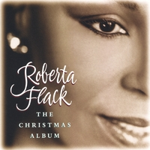  The Christmas Album | 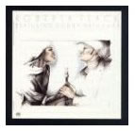  Featuring Donny Hathaway | 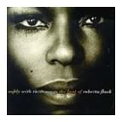  Softly with these Songs
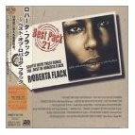  Softly with these Songs (limited edition) | 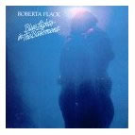  Blue Lights in the Basement | 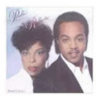  Born to Love
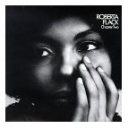  Chapter Two | 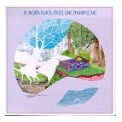  Feel Like Making Love | 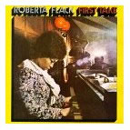  First Take
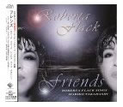  Friends (Japan) | 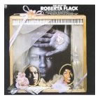  Best of Roberta Flack | 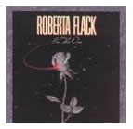  I'm the One
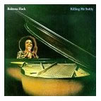  Killing Me Softly | 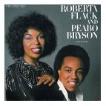  Live and More | 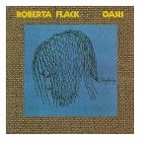  Oasis
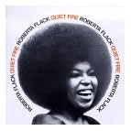  Quiet Fire | 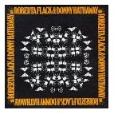  Roberta Flack & Donny Hathaway | 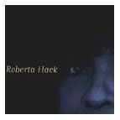  Roberta Flack
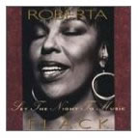
Set the Night to Music

Studio albums
Year | Album
1969 | First Take
1970 | Chapter Two
1971 | Quiet Fire
1972 | Roberta Flack & Donny Hathaway
1973 | Killing Me Softly
1975 | Feel Like Makin' Love
1977 | Blue Lights in the Basement
1978 | Roberta Flack
1980 | Roberta Flack Featuring Donny Hathaway
1982 | I'm the One
1983 | Born to Love (with Peabo Bryson)
1988 | Oasis
1991 | Set the Night to Music
1995 | Roberta

Holiday albums
Year | Album
1997 | The Christmas Album
2003 | Holiday

Soundtracks
Year | Album
1981 | Bustin' Loose

Live albums
Year | Album
1980 | Live & More (with Peabo Bryson)
2008 | At Her Best - Live

Compilation albums
Year | Album
1981 | The Best of Roberta Flack
1984 | Greatest Hits
1993 | Softly with These Songs: The Best of Roberta Flack
2006 | The Very Best of Roberta Flack

Singles
Year | Single | Chart Positions |  |  |  | Album
Year | Single | U.S.  Hot 100 | U.S.  R&B | U.S.  AC | UK | Album
1971 | "You've Got a Friend" (with Donny Hathaway) | 29 | 8 | — | — | Roberta Flack & Donny Hathaway
1971 | "You've Lost That Lovin' Feelin'" (with Donny Hathaway) | 71 | 30 | 36 | — | Roberta Flack & Donny Hathaway
1971 | "Will You Still Love Me Tomorrow" | 76 | 38 | 15 | — | Quiet Fire
1972 | "The First Time Ever I Saw Your Face" | 1 | 4 | 1 | 14 | First Take
1972 | "Where Is the Love" (with Donny Hathaway) | 5 | 1 | 1 | 29 | Roberta Flack & Donny Hathaway
1973 | "Killing Me Softly with His Song" | 1 | 2 | 2 | 6 | Killing Me Softly
1973 | "Jesse" | 30 | 19 | 3 | — | Killing Me Softly
1974 | "Feel Like Makin' Love" | 1 | 1 | 1 | 34 | Feel Like Makin' Love
1975 | "Feelin' That Glow" | 76 | 25 | 38 | — | Feel Like Makin' Love
1977 | "25th of Last December" | — | 52 | 28 | — | Blue Lights in the Basement
1978 | "The Closer I Get to You" (with Donny Hathaway) | 2 | 1 | 3 | 42 | Blue Lights in the Basement
1978 | "If Ever I See You Again" | 24 | 37 | 1 | — | Roberta Flack
1978 | "When It's Over" | — | 82 | — | — | Roberta Flack
1979 | "You Are Everything" | — | 98 | — | — | Roberta Flack
1980 | "You Are My Heaven" (with Donny Hathaway) | 47 | 8 | 46 | — | Roberta Flack Featuring Donnie Hathaway
1980 | "Back Together Again" (with Donny Hathaway) | 56 | 18 | — | 3 | Roberta Flack Featuring Donnie Hathaway
1980 | "Don't Make Me Wait Too Long" | — | 67 | — | 44 | Roberta Flack Featuring Donnie Hathaway
1981 | "Make the World Stand Still" (with Peabo Bryson) | — | 13 | — | — | Live & More
1981 | "Love Is a Waiting Game" (with Peabo Bryson) | — | 46 | — | — | Live & More
1981 | "You Stopped Lovin' Me" | — | 32 | — | — | Bustin' Loose
1982 | "Making Love" | 13 | 29 | 7 | — | I'm the One
1982 | "I'm the One" | 42 | 24 | 10 | — | I'm the One
1982 | "In the Name of Love" | — | 80 | 24 | — | I'm the One
1983 | "Tonight, I Celebrate My Love" (with Peabo Bryson) | 16 | 5 | 4 | 2 | Born to Love
1983 | "Heaven Above Me" (with Peabo Bryson) | — | — | — | 84 | Born to Love
1983 | "You're Lookin' Like Love to Me" (with Peabo Bryson) | 58 | 41 | 5 | — | Born to Love
1984 | "Maybe" (with Peabo Bryson) | — | 68 | — | — | Born to Love
1984 | "I Just Came Here to Dance" (with Peabo Bryson) | — | — | 15 | — | Born to Love
1984 | "If I'm Still Around Tomorrow" (with Sadao Watanabe) | — | 79 | 31 | — | Rendezvous (Sadao Watanabe)
1988 | "Oasis" | — | 1 | 13 | — | Oasis
1989 | "Uh-Uh Ooh-Ooh Look Out (Here It Comes)" | — | 37 | — | 72 | Oasis
1991 | "Set the Night to Music" (with Maxi Priest) | 6 | 45 | 2 | — | Set the Night to Music
1992 | "You Make Me Feel Brand New" | — | 50 | — | — | Set the Night to Music

